MongoDB is an open source, document-oriented, NoSql database whose data is stored in an organized format. It is scalable and easy to learn, commonly used in modern web and mobile apps, dealing with high volumes of data. MongoDB stores data in BSON format, which lets you store JSON like documents efficiently.
This architecture is very well adapted to unstructured or semi-structured data. MongoDB is a great choice to use in applications where you need to support a dynamic schema designs. MongoDB is open-source and is available for free in Linux, Windows, and macOS systems.

Why Learn MongoDB?
Developers use MongoDB because it offers a lot of features for those who like to work with big data. Here are few key reasons of why you should learn MongoDB
- MongoDB is a popular technology for modern web development, particularly high-traffic websites and real-time analytics.
- It provides scalability through sharding and also supports high availability through replication.
- MongoDB can be easily paired with various programming languages such as JavaScript (Node.js), Python, Java and more.
- General corporations like eBay, Uber and Adobe use MongoDB while processing big, unstructured data.
- It offers greater flexibility and faster development time through its schema-less nature.

Introduction to NoSQL
Last Updated : 23 Sep, 2025

NoSQL (Not Only SQL) databases are designed to handle large volumes of unstructured and semi-structured data. Unlike traditional relational databases that rely on fixed schemas and tables, NoSQL offers flexible data models and supports horizontal scaling. This makes them well-suited for modern applications that require high performance, scalability, and the ability to manage diverse data types efficiently.

Key Features of NoSQL Databases
- Dynamic schema: Allow flexible shaping of data to meet new requirements without the need to migrate or change schemas.
- Horizontal scalability: They scale horizontally for adding more nodes into the existing ones and acquire enough storage for even bigger datasets and much higher traffic by distributing the load on multiple servers.
- Document-based: Data are presented in flexible, semi-structured formats like JSON/BSON (e.g., MongoDB).
- Key-value-based: They possess a simple but fast access pattern (e.g., Redis) by storing data as pairs of keys and values.
- Column-based: Data are organized into columns instead of rows (e.g., CASSANDRA).
- Distributed and high availability: They are designed to be highly available and to automatically handle node failures and data replication across multiple nodes in a database cluster.
- Flexibility: Allow developers to store and retrieve data in a flexible and dynamic manner, with support for multiple data types and changing data structures.
- Performance: Perfect for big data and real-time analytics and high volume applications.

Challenges of NoSQL Databases
- Lack of standardization: NoSQL systems can be vastly different from one another, making it even harder to choose the right one for a specific use case.
- Lack of ACID compliance: NoSQL databases may not provide consistency, which is a disadvantage for applications that need strict data integrity.
- Narrow focus: Great for storage but lack functionalities as transaction management, in which relational databases are great.
- Absence of Complex Query Support: They are not designed to handle complex queries, which means that they are not a good fit for applications that require complex data analysis or reporting.
- Lack of maturity: Being relatively new, NoSQL may not have the reliability, security and feature set of traditional relational databases.
- Management complexity: For large datasets, maintaining a NoSQL database could be quite more complicated than managing a relational database.
- Limited GUI Tools: While some NoSQL databases, like MongoDB offer GUI tools like MongoDB Compass, not all NoSQL databases provide flexible or user-friendly GUI tools.

SQL vs. NoSQL:
Feature | SQL (Relational DB) | NoSQL (Non-Relational DB)
Data Model | Structured, Tabular | Flexible (Documents, Key-Value, Graphs)
Scalability | Vertical Scaling | Horizontal Scaling
Schema | Predefined | Dynamic & Schema-less
ACID Support | Strong | Limited or Eventual Consistency
Best For | Transactional applications | Big data, real-time analytics
Examples | MySQL, PostgreSQL, Oracle | MongoDB, Cassandra, Redis

Popular NoSQL Databases & Their Use Cases
NoSQL Database | Type | Use Cases
MongoDB | Document-based | Content management, product catalogs
Redis | Key-Value Store | Caching, real-time analytics, session storage
Cassandra | Column-Family Store | Big data, high availability systems
Neo4j | Graph Database | Fraud detection, social networks

Use of NoSQL
- Big Data Applications: Efficiently stores and processes massive amounts of unstructured and semi-structured data.
- Real-Time Analytics: Supports fast queries and analysis for use cases like recommendation engines or fraud detection.
- Scalable Web Applications: Handles high traffic and large user bases by scaling horizontally across servers.
- Flexible Data Storage: Manages diverse data formats (JSON, key-value, documents, graphs) without rigid schemas.

Features of the MongoDB database
MongoDB offers several key features that make it efficient and scalable:
- Document Oriented: Stores all related data together in a single, flexible document rather than multiple tables.
- Indexing: Enables fast queries by avoiding full collection scans, crucial for handling large data efficiently.
- Scalability: Uses sharding to distribute data across multiple servers; easily add new machines to expand.
- Replication and High Availability: Stores multiple data copies on different servers for redundancy and fault tolerance.
- Aggregation: Processes and summarizes data (like SQL GROUP BY) using operations such as sum, avg, min, and max.

Real-World Applications of MongoDB

Real-World Applications of MongoDB

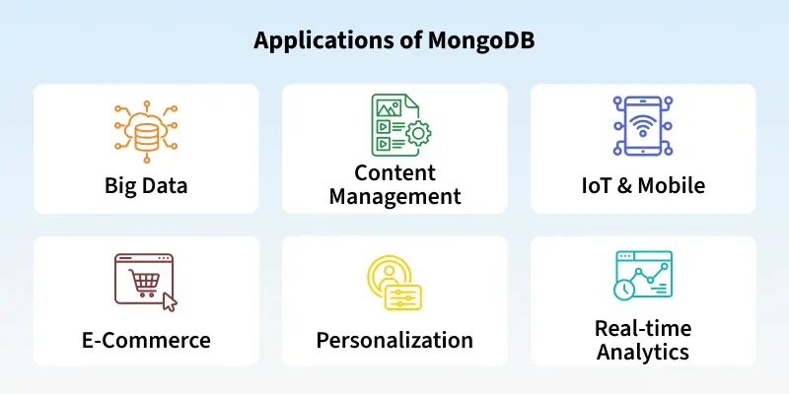

MongoDB powers a wide range of modern applications:
- Websites & Apps: Platforms like e-commerce sites use MongoDB to store product catalogs, user profiles, and order histories.
- Real-Time Analytics: Companies analyze user activity or sales trends on the fly, such as tracking popular products during a sale.
- Content Management & Personalization: Apps manage dynamic content and personalize recommendations, like suggesting movies based on viewing history.
- Big Data & IoT: MongoDB handles large volumes of unstructured data from sensors, logs, or social media feeds for processing and insights.

MongoDB powers a wide range of modern applications:
- Websites & Apps: Platforms like e-commerce sites use MongoDB to store product catalogs, user profiles, and order histories.
- Real-Time Analytics: Companies analyze user activity or sales trends on the fly, such as tracking popular products during a sale.
- Content Management & Personalization: Apps manage dynamic content and personalize recommendations, like suggesting movies based on viewing history.
- Big Data & IoT: MongoDB handles large volumes of unstructured data from sensors, logs, or social media feeds for processing and insights.

How MongoDB works ?
Last Updated : 17 Jul, 2025

MongoDB is an open-source document-oriented database. It is used to store a larger amount of data and also allows you to work with that data. MongoDB is not based on the table-like relational database structure but provides an altogether different mechanism for storage and retrieval of data, that is why known as NoSQL database. Here, the term ‘NoSQL’ means ‘non-relational'. The format of storage is called BSON ( similar to JSON format).

Components of MongoDB
Now, let's see how actually this MongoDB works? But before proceeding to its working, first let us discuss some important concepts that make MongoDB function smoothly.

1. Drivers
Drivers are client libraries that offer interfaces and methods for applications to communicate with MongoDB databases. It supports various drivers which enables it to work on different programming languages. Some of the popular drivers are C, C++, C# and .Net, Go, Java, Node.js, Perl, PHP, Python, Motor, Ruby, Scala, Swift, Mongoid.

2. MongoDB Shell
MongoDB Shell or mongo shell is an interactive JavaScript interface for MongoDB. For dealing with MongoDB databases, MongoDB provides the MongoDB Shell command-line interface (CLI) tool. It is used for running queries, data updates and it also performs administrative operations such as backups, restores etc.
After installing MongoDB, you may access the MongoDB Shell, often known as mongo. It interacts with the database using JavaScript-based syntax. Additionally, it has built-in help that shows details about possible commands and how to use them.

3. Storage Engine
- It is an important part of MongoDB which is generally used to manage how data is stored in the memory and on the disk.
- You are allowed to use your own search engine and if you don't want to use your own search engine, you can use the default search engine, known as WiredTiger Storage Engine.
- It is an excellent storage engine, it efficiently works with your data like reading, writing, etc.
MongoDB can have multiple search engines.
Storage Engine | Description | Use Case
WiredTiger | Default storage engine since MongoDB 3.0. It supports document-level concurrency and data compression. | Ideal for high-performance, write-intensive applications.
In-Memory Engine | Stores data in RAM instead of disk, ensuring ultra-fast access. | Suitable for real-time data processing and caching.
MMAPv1 | Based on memory-mapped files, designed for read-heavy workloads. It was deprecated after MongoDB 4.0. | Read-heavy applications (use is now discouraged, as it's deprecated).

Working of MongoDB
MongoDB works on two layers: the Application Layer and the Data Layer. The following image shows the working of MongoDB.

1. Application Layer
Application Layer is also known as the Final Abstraction Layer. It has two-parts, first is a Frontend (User Interface) and the second is Backend (server).

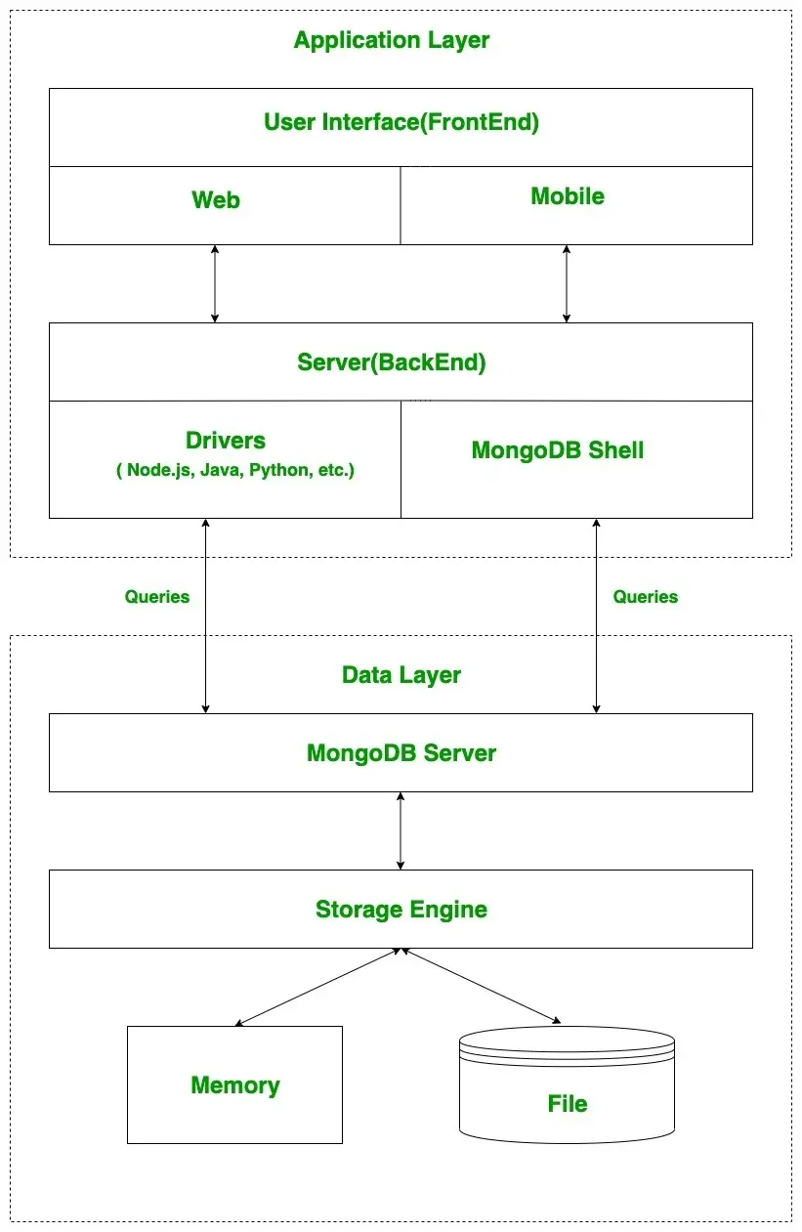

- Frontend (User Interface): It is the place where user uses MongoDB with the help of a Web or Mobile. These web and mobile include web pages, mobile applications, android default applications, IOS applications, etc.
- Backend(Server): The backend contains a server which is used to perform server-side logic and also contains drivers or mongo shell to interact with MongoDB server with the help of queries. These queries are sent to the MongoDB server present in the Data Layer.
The frontend sends requests to the backend and the backend uses MongoDB drivers to communicate with the MongoDB server in the Data Layer.

2. Data Layer
The Data Layer is where MongoDB stores and processes data. This layer contains:
- MongoDB server: The server receives queries from the application and passes the received queries to the storage engine. MongoDB server itself does not directly read or write the data to the files or disk or memory
- Storage Engine: After passing the received queries to the storage engine, the storage engine is responsible to read or write the data in the files. It manages how data are stored in memory or disk.
Note: Reading and writing from memory are much faster than from disk. MongoDB optimizes this by using memory for frequent data access and disk for long-term storage.

How the Data Flow Works in MongoDB
- User Interactions: A user interacts with the application (frontend), sends requests (queries).
- Backend Processing: The backend (server) receives these requests and communicates with MongoDB using drivers or the Mongo shell.
- MongoDB Server: The MongoDB server receives the queries and forwards them to the storage engine.
- Storage Engine: The storage engine reads or writes data from/to memory or disk, based on the query.

Conclusion
- Key components like drivers, the mongo shell, and the storage engine make MongoDB efficient and easy to use.
- The system works in two layers: Application Layer (Frontend + Backend) and Data Layer (MongoDB Server + Storage Engine).
- The backend communicates with the MongoDB server, which processes data in the storage engine and handles reading and writing operations.

Features of MongoDB
MongoDB offers a wide range of features that make it a preferred choice for modern applications.

1. Schema-less Database
Unlike traditional relational databases, MongoDB collections:
- Allow different structures within the same collection.
- Do not require fixed column definitions.
- Enable easy updates and modifications.

2. Document Oriented
In MongoDB, all the data stored in the documents instead of tables like in RDBMS. In these documents, the data is stored in fields(key-value pair) instead of rows and columns which make the data much more flexible in comparison to RDBMS. And each document contains its unique object id.

3. Indexing
In MongoDB database, every field in the documents is indexed with primary and secondary indices this makes easier and takes less time to get or search data from the pool of the data. If the data is not indexed, then database search each document with the specified query which takes lots of time and not so efficient.

4. Scalability
MongoDB provides horizontal scalability with the help of sharding. Sharding means to distribute data on multiple servers, here a large amount of data is partitioned into data chunks using the shard key, and these data chunks are evenly distributed across shards that reside across many physical servers. It will also add new machines to a running database.

5. Replication
MongoDB provides high availability and redundancy with the help of replication, it creates multiple copies of the data and sends these copies to a different server so that if one server fails, then the data is retrieved from another server.

6. Aggregation
It allows to perform operations on the grouped data and get a single result or computed result. It is similar to the SQL GROUPBY clause. It provides three different aggregations i.e, aggregation pipeline, map-reduce function, and single-purpose aggregation methods.

7. High Performance
The performance of MongoDB is very high and data persistence as compared to another database due to its features like scalability, indexing, replication, etc.

What is MySQL?
MySQL is an open-source relational database management system (RDBMS) that uses Structured Query Language (SQL) to manage data. Developed by MySQL AB and now owned by Oracle Corporation, it’s widely used due to its reliability, speed, and ease of use. MySQL is a key component in many web applications, forming the backbone of popular websites and services.
It allows users to create, modify, and maintain databases, supporting operations like data insertion, querying, updating, and deletion. Ideal for both small and large-scale applications, MySQL powers various types of systems, from personal projects to complex enterprise environments.
MySQL is a Relational Database Management System (RDBMS) software that provides many features, which are as follows:
- Data Storage: Efficiently stores large amounts of data.
- Data Retrieval: Allows quick and easy access to data.
- Data Manipulation: Supports operations like inserting, updating, and deleting data.
- Data Security: Offers robust security features to protect data.
- Scalability: Can handle small to large applications with ease.

How MySQL Works?
MySQL works like this:
- Client Request: You send a request to the MySQL server using an application or a command-line tool.
- Connection: The server connects with your application to start a session.
- SQL Parsing: The server checks your SQL query for any errors.
- Query Optimization: The server figures out the best way to execute your query efficiently.
- Execution: The server runs the query. It reads or writes data to the database as needed.
- Storage Engine: This is where data is stored on the disk. MySQL uses different storage engines like InnoDB or MyISAM for this.
- Result Generation: The server creates the result based on your query.
- Response: The server sends the results back to your application.
- Client Interaction: Your application displays the data to you.
- Transaction Management: For complex operations, MySQL ensures everything runs smoothly and data remains accurate.
- Logging and Recovery: MySQL keeps logs to help recover data if something goes wrong.
- Replication and Backup: MySQL can copy data to other servers for safety and better performance. It also supports data backups to keep your information safe.

Mongodb Interview questions:-
https://www.interviewbit.com/mongodb-interview-questions/

Mysql Interview questions:-
https://www.interviewbit.com/mysql-interview-questions/

MongoDB vs MySQL
Last Updated : 14 Jul, 2025

Both MongoDB and MySQL are popular database management systems (DBMS), but they are built for different purposes and have distinct features. MongoDB is a NoSQL database, designed for handling unstructured data with high scalability, while MySQL is a traditional relational database management system (RDBMS), ideal for structured data with complex relationships.

Difference Between MongoDB and MySQL
Here is a detailed comparison of MongoDB and MySQL based on various features:
Feature | MongoDB | MySQL
Database Type | NoSQL (Document-oriented) | SQL (Relational)
Data Model | Flexible schema with collections and documents | Structured data with tables and rows
Query Language | MongoDB Query Language (MQL) | Structured Query Language (SQL)
Scalability | Horizontal scaling (sharding) | Vertical scaling (replication and clustering)
Performance | High performance with large data sets | Excellent for complex queries and joins
Data Integrity | Eventual consistency (no ACID compliance) | Strong consistency with ACID compliance
Schema | No predefined schema; flexible schema design | Fixed schema with predefined tables and columns
Transactions | Limited support for multi-document transactions | Full ACID support for multi-row transactions
Use Cases | Big Data, Content Management Systems, Real-time Analytics | Banking Systems, E-commerce, Enterprise Applications
Replication | Replica sets for high availability | Master-slave replication
Indexing | Supports various types of indexes (hashed, compound) | Supports various indexes (primary, unique, full-text)
Data Integrity | Limited to eventual consistency | ACID-compliant, ensuring full data integrity

Mongodb queries-
https://www.mongodb.com/docs/manual/tutorial/query-documents/
Mysql queries: -
https://www.geeksforgeeks.org/sql/sql-ddl-dql-dml-dcl-tcl-commands/

